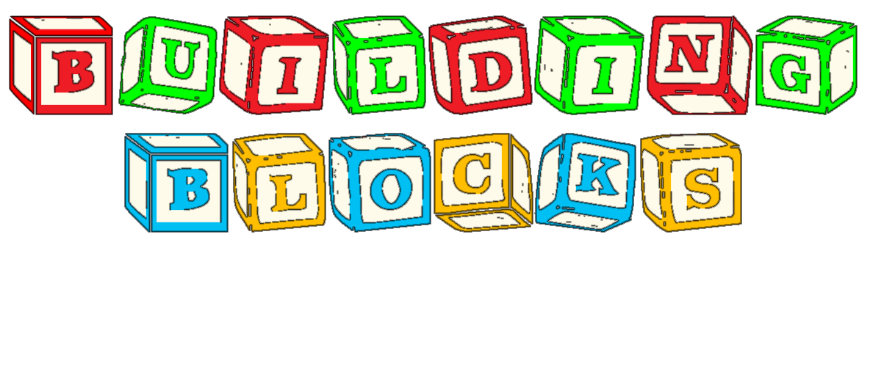

LEARNING CENTRE

A positive place where kids can learn, socialize, and play in a fun, easy going way!
Preschool
(Updated September 2024)
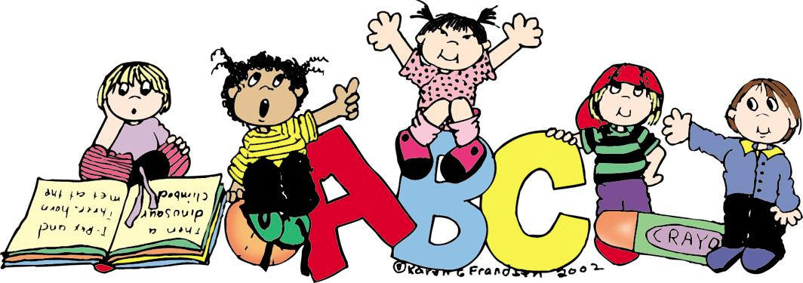

*Licensed Centre *Qualified Staff
Parent Handout
9060 212th Street
Walnut Grove, BC
604-613-7910
buildingblocksabc@gmail.com
www.buildingblockslearningcentre.ca
Welcome to Building Blocks Learning Centre
Preschool
Philosophy
Our centre’s goal is to provide a safe, positive environment for your child to learn, socialize, and have fun. Play and repetition is the medium for learning at Building Blocks Learning Centre. We provide the best opportunities for this type of learning to take place.
Our objectives are:
- To encourage the development of problem solving skills and self help skills.
- To enhance the large and small motor skills.
- To provide an opportunity to explore a variety of sensory experiences.
- To be aware and handle their feelings.
- To provide opportunities to be social among other children, adults, and parents.
- To understand words and numbers to be prepared for kindergarten.
Guidance and Discipline Policy
The centre’s policy is to provide a positive and consistent environment. We like to have good communication when dealing with behaviour issues.
To provide a positive setting for limits and expectations, we acknowledge feelings that the child is portraying and focus on the child’s behaviour, rather than on the child.
Our main strategy at the centre is to teach self-help skills through problem solving. This includes the child identifying the problem, and working out a solution (with teachers’ help if needed).
Time out is not apart of our program at Building Blocks Learning Centre. However, we do use a thinking chair to have the child reflect their actions and talk about a more suitable solution for next time.
If there are any changes or stresses in your child’s life please inform the staff as these changes do affect behaviour. If the staff is aware of any stresses we can be there to help the child with their personal needs.
Any child portraying challenging behaviour will be discussed with parents to develop a plan for management. We will work together to minimize the behaviour to make it more manageable.
We believe, and act on the belief that in all disciplinary strategies we will strive to pursue a course of action that will enhance a child’s self concept, and that all our techniques will display a basic respect for the integrity of the individual child. No disciplinary action will be acceptable if it is intended to lower a child’s self esteem. Discipline is something we work through with the children, not do to them!
We do not physically hit, humiliate, withhold food, or ridicule a child in any form. Abuse is not the answer. In the centre the following actions are forbidden:
Physical Abuse; Defined as any physical force or action which results in or may potentially result in a non-accidental injury to a child and which exceeds reasonable discipline.
Sexual Abuse; Defined as any sexual touching, sexual intercourse or sexual exploitation of a child. It may include any sexual behaviour directed toward a child or the request by an abuser that a child performs sexual acts.
Emotional Abuse; Defined as actively undermining a child's self-image, sense of worth and self-confidence.
Physical Neglect; Defined as the failure on the part of those responsible for the care of a child to provide for the physical, emotional, or medical needs of a child to the extent that a child's health, development or safety are endangered.

If the centre suspects forms of abuse inside the facility it is our duty to inform Community Care Facilities Licensing at 604-930-5405. If the centre suspects abuse outside the facility it is our duty as a caregiver to report this to the Children and Family Development at 604-514-2711. Any suspicions are taken very seriously and it is our duty to ensure the safety of everyone in our program. All suspected abuse reports are confidential. After all the children's safety does come first!
We will use language to guide and discipline a child. This language will be used within strategies that focus on positive behaviour and model good, respectable communication skills.
These positive discipline strategies will intend to make a distinction between the child and their behaviour, state limits in a positive way, and make an effort to acknowledge the child’s feelings before setting limits. It is more effective to shape and reinforce positive behaviour then to continually focus all our energy and attention on bad behaviour.

Behaviour Mangament
We will use language to guide and discipline a child. This language will be used within strategies that focus on positive behaviour and model good, respectable communication skills.
These positive discipline strategies will intend to make a distinction between the child and their behaviour, state limits in a positive way, and make an effort to acknowledge the child’s feelings before setting limits. It is more effective to shape and reinforce positive behaviour then to continually focus all our energy and attention on bad behaviour.
Building Blocks Learning Centre is a childcare program that offers quality care for children ages 30 months to 12 years old. Our mission is to provide a safe, secure environment that helps children grow through postive play. Licensing mandates that all children are kept safe from harm.
In an effort to provide a safe, secure, enriching, developmentally cohesive environment for your child, the children and staff at Building Blocks Learning Centre will not be subject to threatening, violent or abusive behaviour by any other individuals. The philosophy of our centre is:
a) Each child be treated with respect and dignity
b) Each child be provided with a safe, nurturing, stable environment
c) Each child is provided with a stimulating environment that encourages their individual development.
The following are reasons for Building Blocks Learning Centre suspend/withdraw care of your child:
- Violent behaviour causing harm to themselves, other children or staff.
- Willful destruction of any personal or daycare property.
- Dangerous/excessive behaviour resulting in putting other children and/or staff at risk.
If the behaviour or the situation does not improved after written warning by the staff you will be advised that alternate care needs to be found.
Health Policy
Parents must provide a name of a reliable person who can act as alternative care for a child who is sick or has had an accident.
Our centre needs your child’s immunization records up to date. Information can be given by contacting the Health Unit or family doctor.
In order to keep our centre a healthy environment, sick or contagious children must stay at home until they are better. If your child is having any of the following symptoms you must keep them home until they are no longer feeling them:
- Pain-Any complaints of unexplained or undiagnosed pain.
- Acute cold or fever, severe runny nose and eyes, coughing and sore throat (all the above while child is contagious).
- Difficult breathing such as wheezing, or consistent cough.
- Fever (100F or 38.3C).
- Sore throat or difficulty swallowing.
- Infected skin or eyes, or an undiagnosed rash.
- Diarrhea.
- Nausea and/or vomiting.
- Headache or stiff neck.
- Severe itching of the body or scalp.
- Children with unknown or suspected communicable diseases (example: Chicken pox).
The centre has the services of a public health nurse available. The services used if there is a need concerning a child’s physical, emotional, and mental well being. Please speak to staff if you have any concerns.
At Building Blocks Learning Centre we encourage health and nutrition. Please bring healthy snacks to the centre. If you need any suggestions please feel free to ask any of the staff.
Reportable Incidents
Reportable incidents is an event where a child or staff member has been injured to the degree of going to a clinic or hospital, potentially abused, or gone missing while under the care of Building Blocks Learning Centre. It could also be a disease outbreak at the centre. All reportable incidents would be reported within 24 hours of the incident and sent to our local Licensing officer where an investigation would occur.
Release of Child
Only People who are written on the registration form will be the only people that may pick up a child from the centre. If a parent writes a note or calls the centre we may make considerations to the pick up list. If there are any custody issues we will have to have a copy of the custody agreement to withhold a child from the parent.
If a child is still at the centre at closing time, parents will be called. If we cannot reach a parent we will phone all other authorized contacts. If the child is not picked up within the hour it is our duty to call Ministry of Child and Family Development. If an authorized parent/person looks under the influence of any substance we have the right to notify police right away. Further investigation will then take place.
Fire/Earthquake Drills and Emergency Evacuation Plan
Fire and earthquake drills are scheduled and practiced monthly. All drills are dated and documented. You will find them documented on the wall for staff, parents, fire department and licensing to see.
If there is ever an emergency such as a fire, earthquake, flood, or gas leak and we need to evacuate the premises we will meet at the Walnut Grove Community Centre located at 8889 Walnut Grove Drive. The phone number there is 604-882-0408. We will walk there as a group until all the children are picked up by their parent/ guardian. If the Centre’s phone (604-613-7910) or our local emergency number is not working you may get in contact with my brother in law, Kris who lives in Kelowna. He can be reached at 250-899-0604 so we can stay in contact with each other.
In the centre there will be a bin full of food, water, and supplies to last up to 72 hours. This is also where the children’s individual care packages will be stored. This will be located in the corner of the centre. All staff and helpers working in the centre will be constantly reminded where the emergency bin and emergency cards are and what to do if an emergency ever occurs.
Hours of Operation
AM Class: 9:00am-11:30AM PM Class: 12:00PM-2:30PM Extended Program: 9:00AM-1:00PM
Closed Pro-D days, holidays, Christmas / Spring Break, and Summer. (follow the school calendar)

Description of Program
Children who attend Building Blocks Learning Centre will have a range of activities to learn from. The children will enter the classroom and find their name to put away. This awareness will help recognize their name and letters. We will sit down as a class and join in on circle time games, songs, and stories. Each month we will focus on a different theme to learn about. Following our circle will be time for art, math, science, and imaginary play. We will then sit down, have a snack and go outside, weather permitting... Gross motor is important for developing their bodies and self-esteem so we always make time for outside time rain or shine. If weather is too extreme to go outside we will play movement games inside such as parachute. We will then finish the day off by coming inside and having a quiet story and songs.
Fees and Fee Payment Policies and Procedures
3 days/week: Mon/Wed/Fri $225/month After reduction: $168/month
Extended care: Mon/Wed/Fri $345/month After reduction: $288/month
2 days/week: Tues/Thurs $190/month After reduction: $154/month
Extended care: Tues/Thurs. $230/month After reduction: $194/month
Extended care: Mon-Fri. $575/month After reduction: $480/month

Building Blocks Learning Centre is part of the Childcare Fee Reduction Initiative program where the government helps pay partial fees for preschool. The cost from the parent is reduced and is calculated above.

The centre requires post-dated cheques dated the 1st of each month.
*Subject to estimated 3% increase each September.

Late Pick Up Fee:
The fee is $1 per minute you are late picking up your child. This will hopefully encourage all parents to pick up their children on time.

Admission and Attendance Policies and Procedures
At Building Blocks Learning Centre there is an admission to secure your child’s spot of $50.00. This is required with your registration papers.
One month’s written notice is required upon parental withdraw from the preschool. One month’s fees will be withheld in the event that there is no notice given.
The preschool has the right to give you as a parent or guardian, one months notice to have your child withdrawn from the program.
There will be an attendance book out at all times. You must sign your child in and out every time your child attends. There is a sign in sheet provided at the front of the class. Provincial childcare laws forbid us to allow a child to leave with another child under 12 years of age. Please notify the staff if someone other than yourself is picking up your child, or we cannot permit them to leave.
Active Play/Screen Time
Our preschool program makes time to go outside everyday for a minimum of 15 minutes per class. We ask all children bring the appropriate attire to school for the weather that day. If there are extreme weather conditions then we will play a gross motor activity inside to get their bodies actively moving.
Child Care Licensing Regulations promotes Centre’s to limit the use of screen time. Our preschool believes children do not need it during our program so we do not have any TV/Tablets/Computers at our preschool, and we ask all families to keep all electronics at home.
Confidentiality
Any pertinent information given to the staff will always be kept on confidentiality. Feel free to speak to us with any concerns you are having concerning your child. We are also there to listen to anything you feel you would like to tell us.
Special Events
We celebrate all holidays and special occasions, such as birthdays, at our centre. We also do fieldtrips usually once a month. All fieldtrips are parent participation and we meet at the place. Information about these days will be given out through newsletters and bulletins.
Photos
Here at Building Blocks we take pictures of the children all year round to have a memory of their time here. If you do not wish to have your child’s picture been taken please notify the staff with a note stating you do not wish to have your child’s picture been taken.
Clothing
Please dress your child according to weather. Be advised we do go outside on snowy or rainy days. Please have an extra pair of clothing and shoes at all times at the centre. Also remember our centre is play-based and your child will more than likely get dirty.

Hope to See You Soon At Building Blocks Learning Centre Preschool!

